Week 08

**Question 1:**

**Coders here is a simple task for you, you have given an array of size *N* and an integer *M*. Your task is to calculate the *difference between maximum sum and minimum sum of N-M* elements of the given array.**

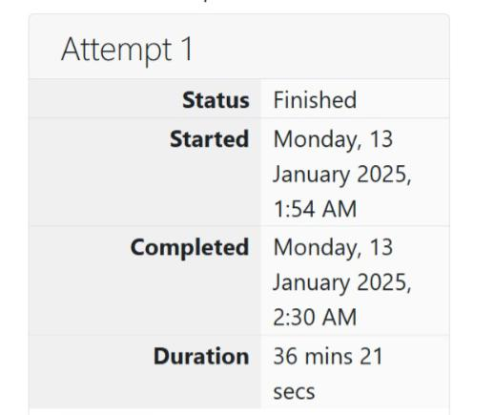

**Program:** 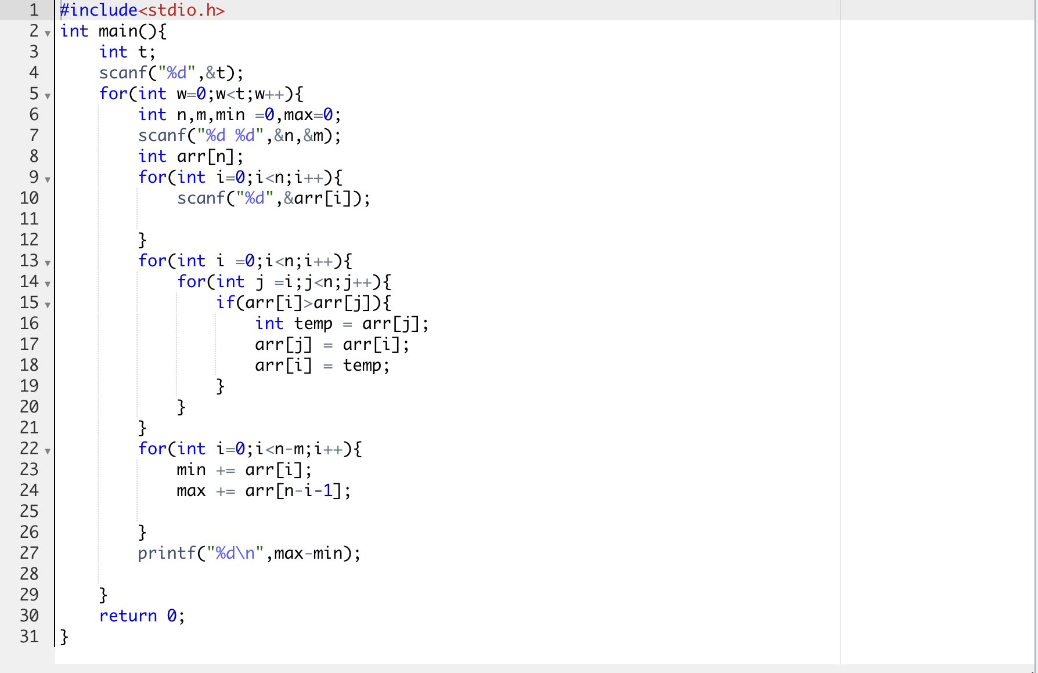

**Output:**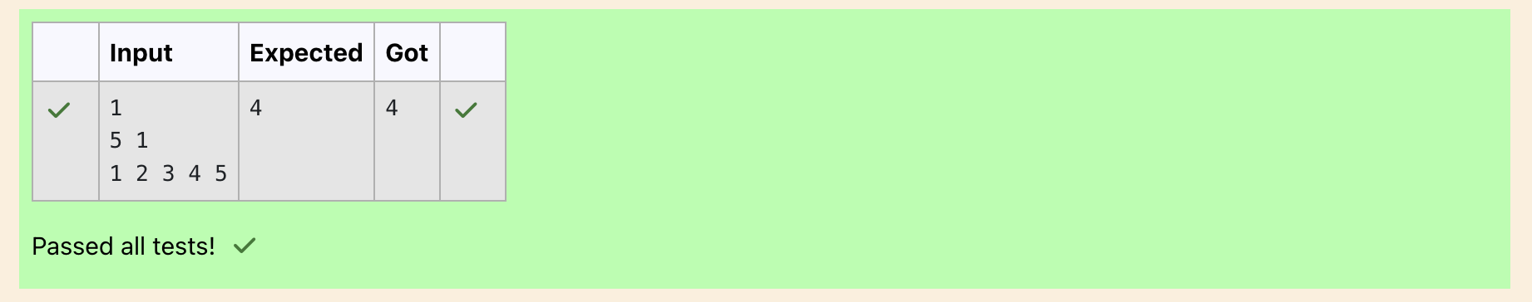

**Question 2:**

**A new deadly virus has infected large population of a planet. A brilliant scientist has discovered a new strain of virus which can cure this disease. Vaccine produced from this virus has various strength depending on midichlorians count. A person is cured only if midichlorians count in vaccine batch is more than midichlorians count of person. A doctor receives a new set of report which contains midichlorians count of each infected patient, Practo stores all vaccine doctor has and their midichlorians count. You need to determine if doctor can save all patients with the vaccines he has. The number of vaccines and patients are equal.**

**Program:** 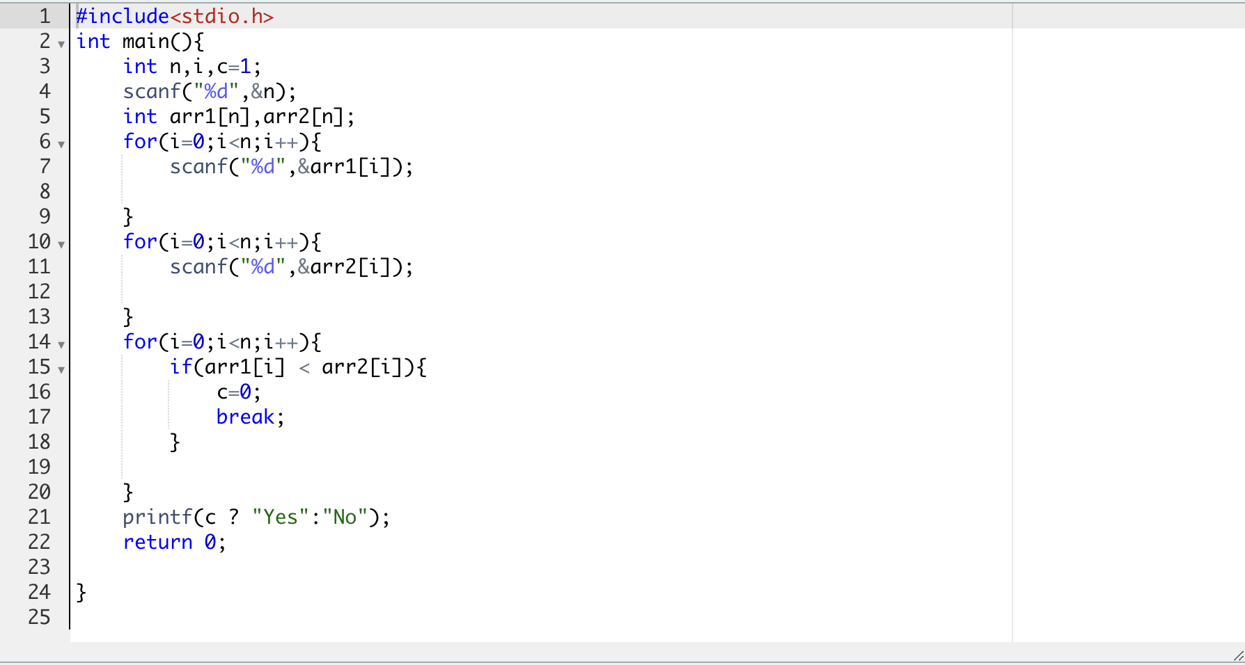

**Output:**

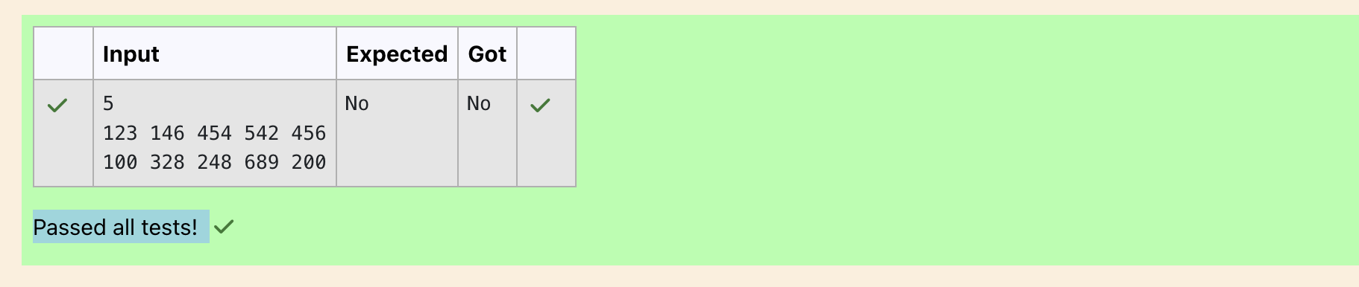

**Question 3:**

**You are given an array of n integer numbers *a1, a2, . . . , an*. Calculate the number of pair of indices *(i, j)* such that *1 ≤ i < j ≤ n* and *ai* xor *aj = 0*.**

**Program:** 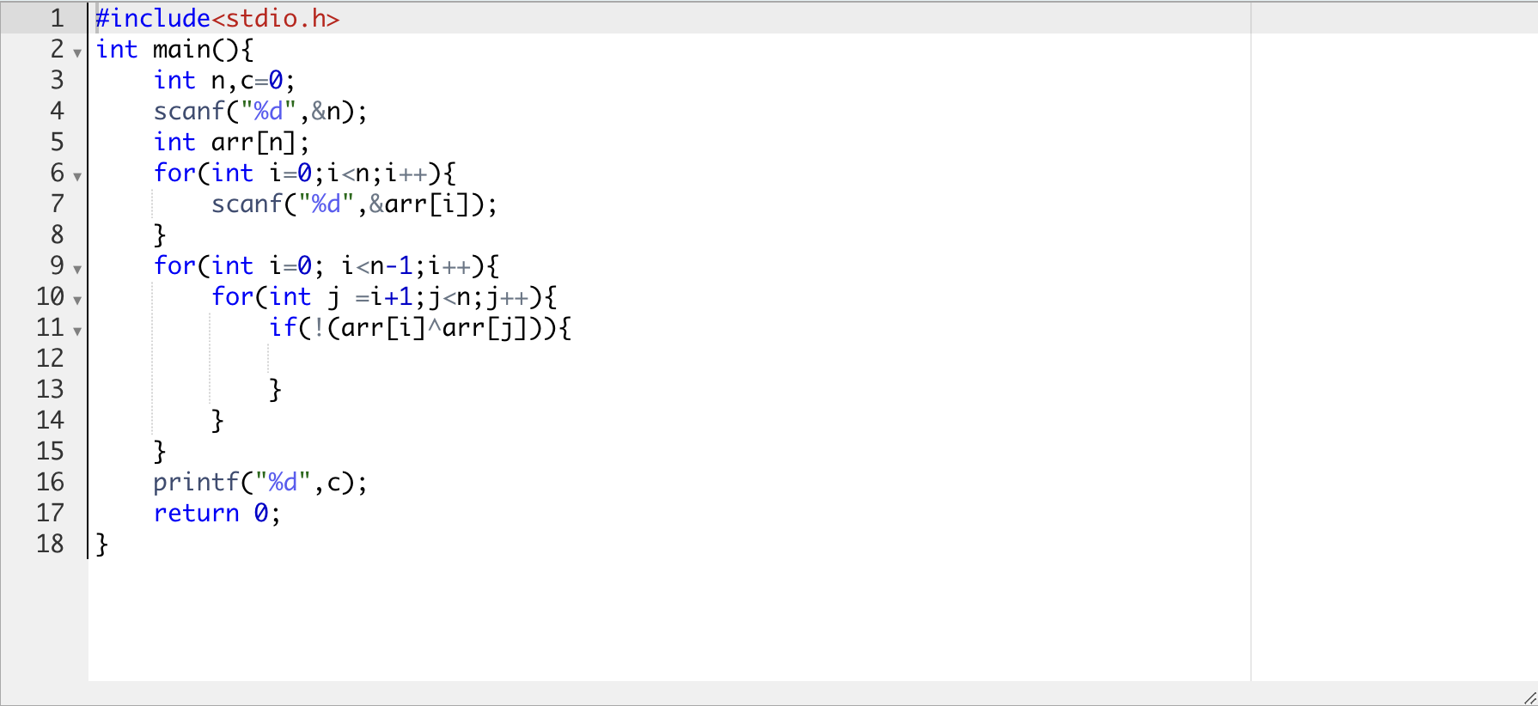

**Output:**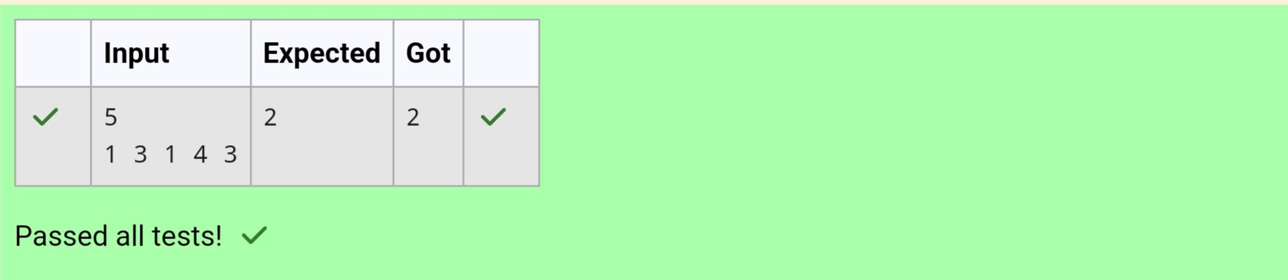

**Question 4:**

**You are given an array *A* of non-negative integers of size *m*. Your task is to sort the array in non-decreasing order and print out the original indices of the new sorted array.**

**Program:** 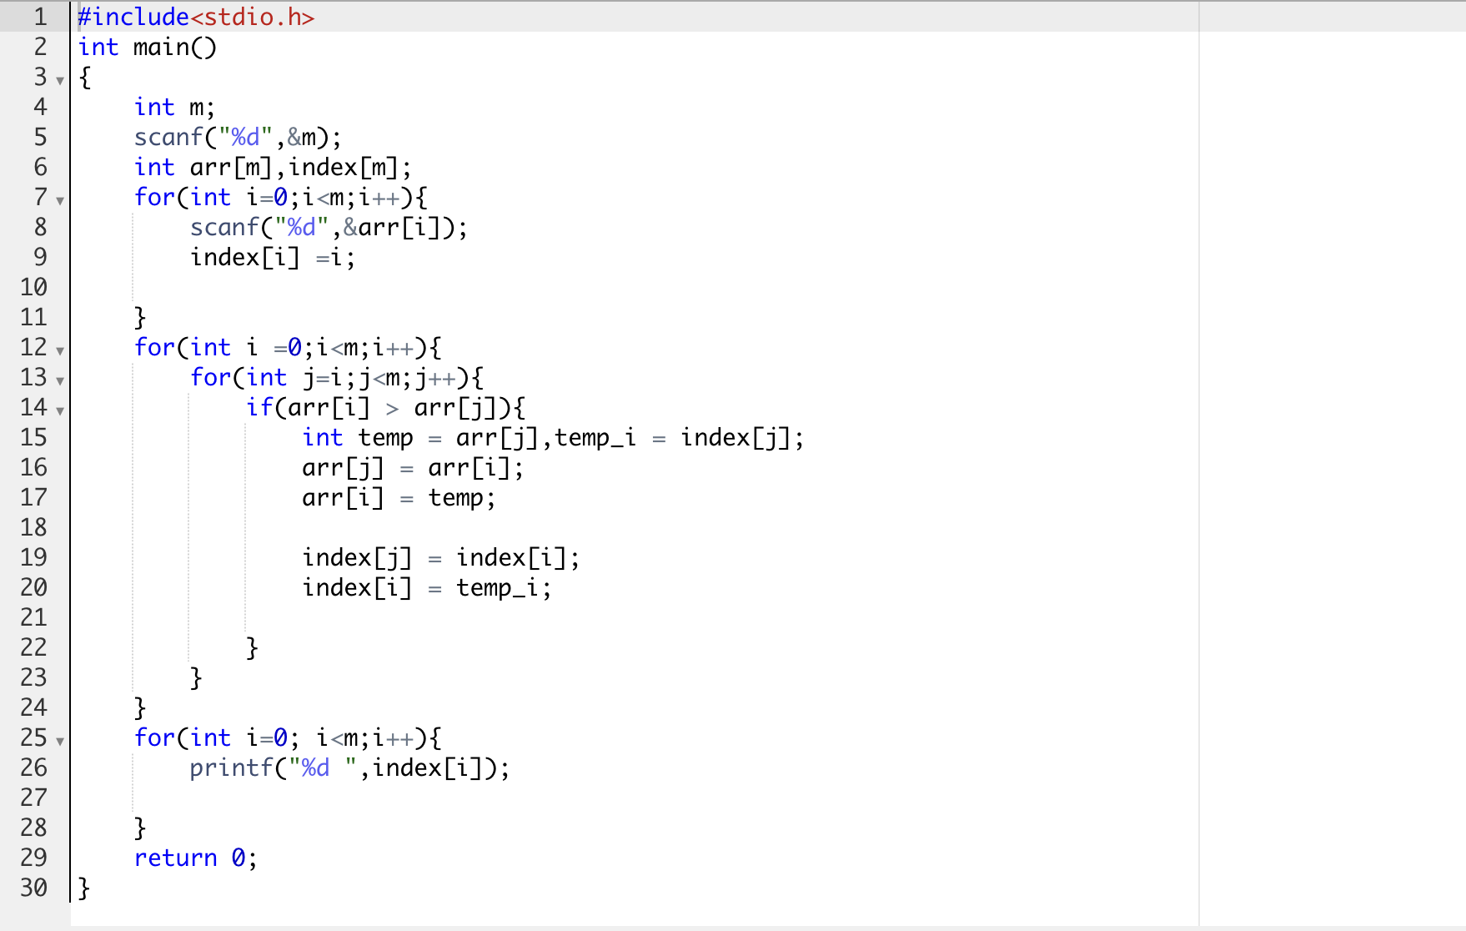

**Output:**

